Window IOT Beginner Kit

Hardware List:

* Raspberry Pi 2
* Arduino Expansion Shield for Raspberry Pi B+
* Magnet Micro USB Cable
* CAT 5 Ethernet Cable
* HDMI Cable
* Micro SD Memory Card 16GB Class10
* USB Keyboard
* USB Mouse

Hardware Connection:

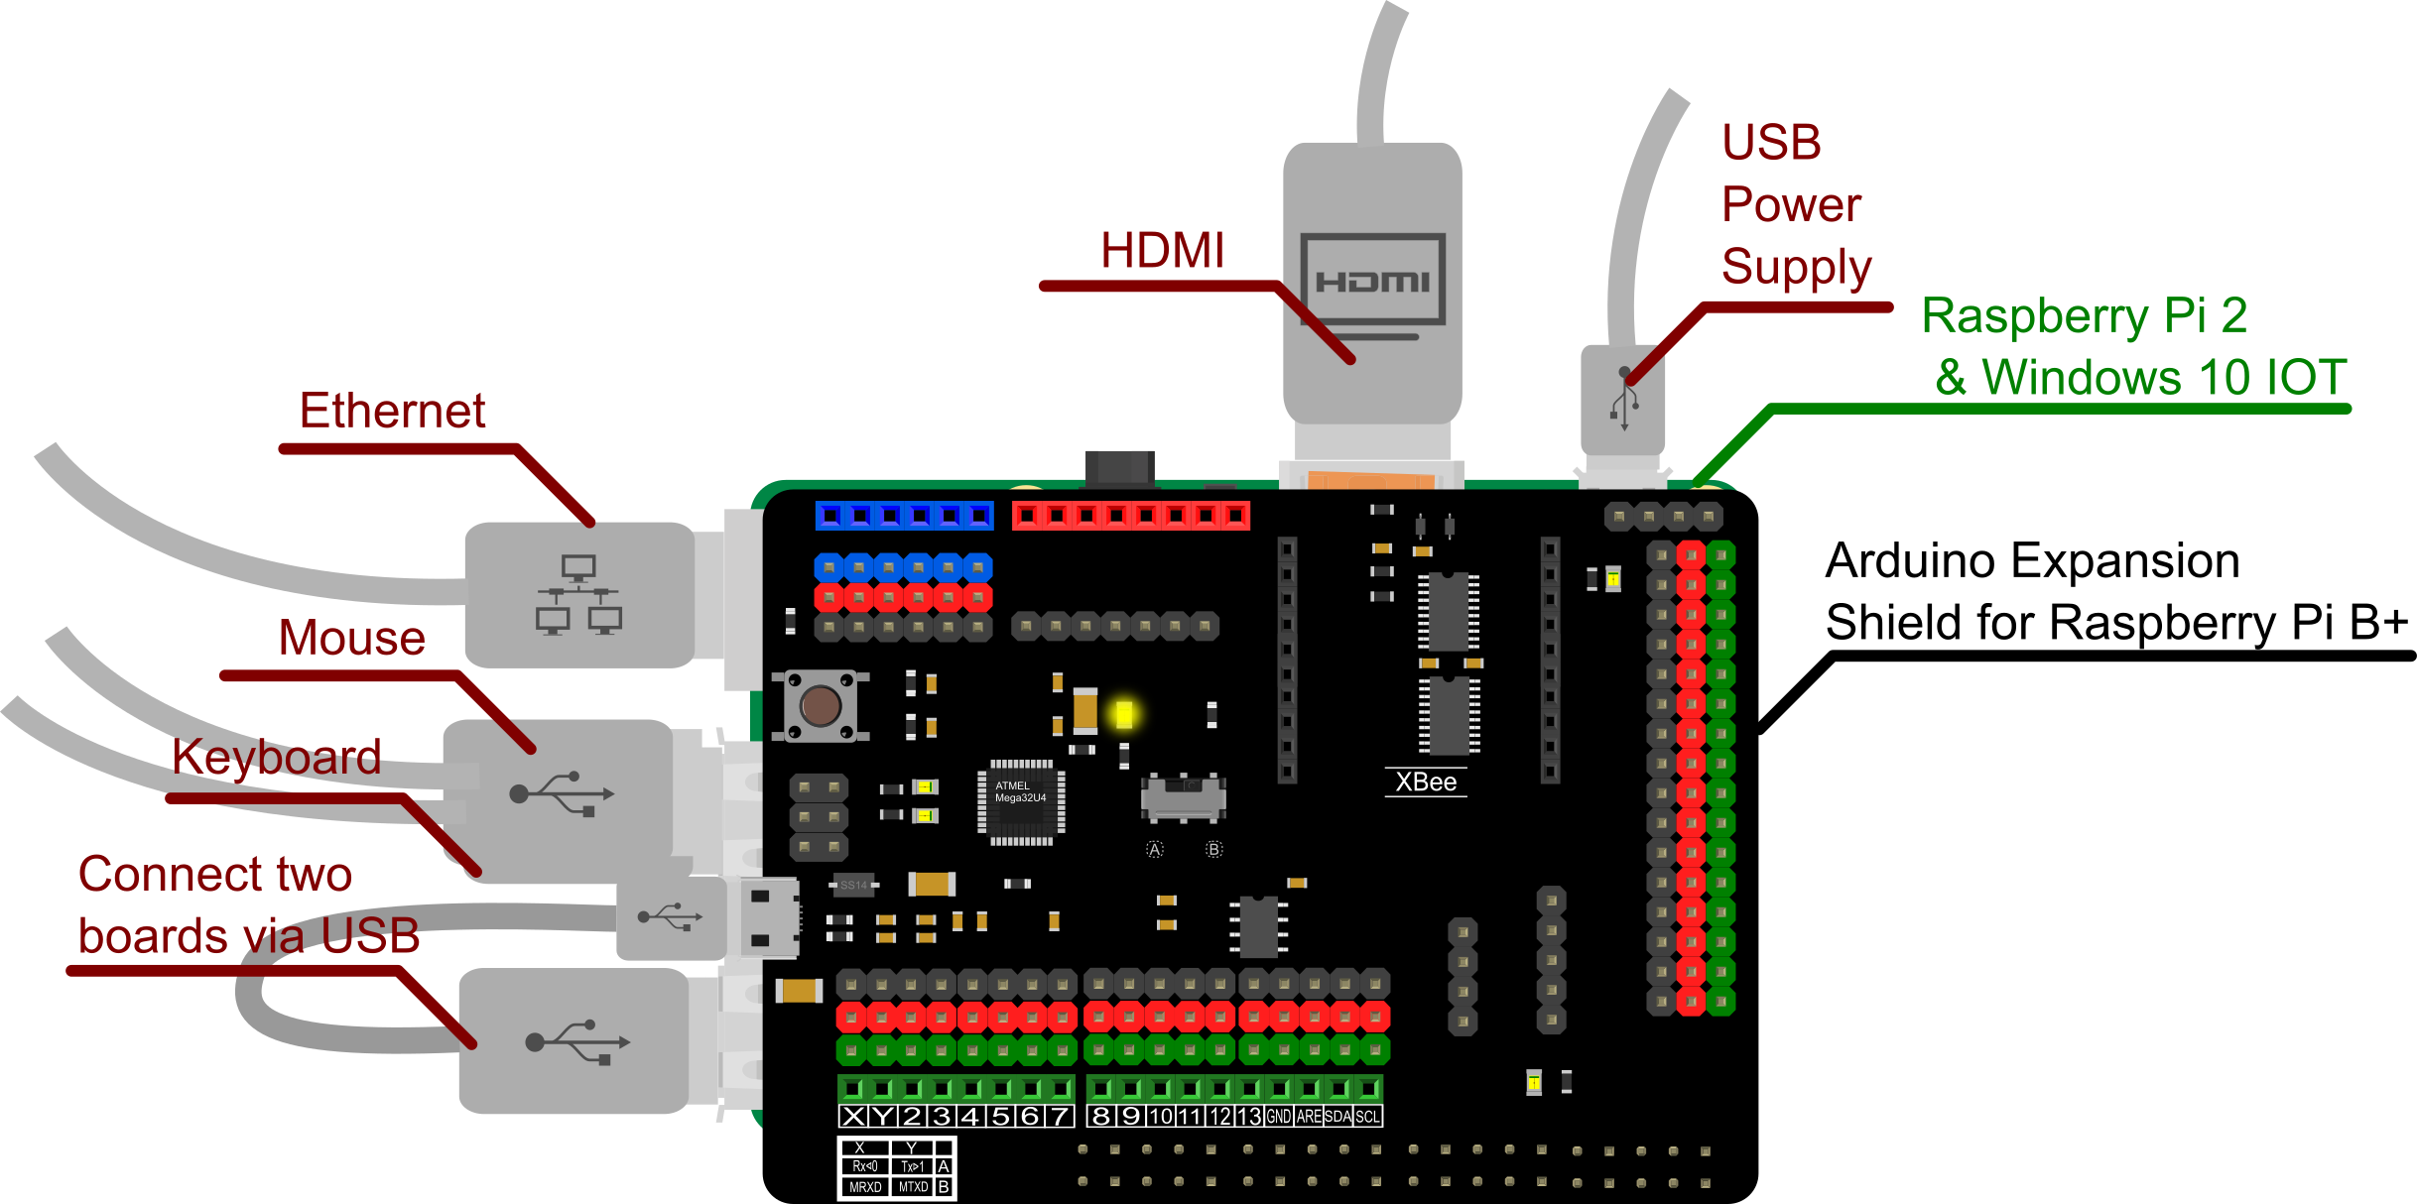

1. Plug the “Arduino Expansion Shield for Raspberry Pi B+” onto the Raspberry Pi 2
2. Connect Ethernet, mouse, keyboard, HDMI.
3. Connect Two boards via USB.
4. Insert the Micro SD card into Raspberry Pi.
5. Connect USB Power Supply.
6. After windows 10 IOT is successfully booted. Some basic device information is there and you can use your mouse to control it.

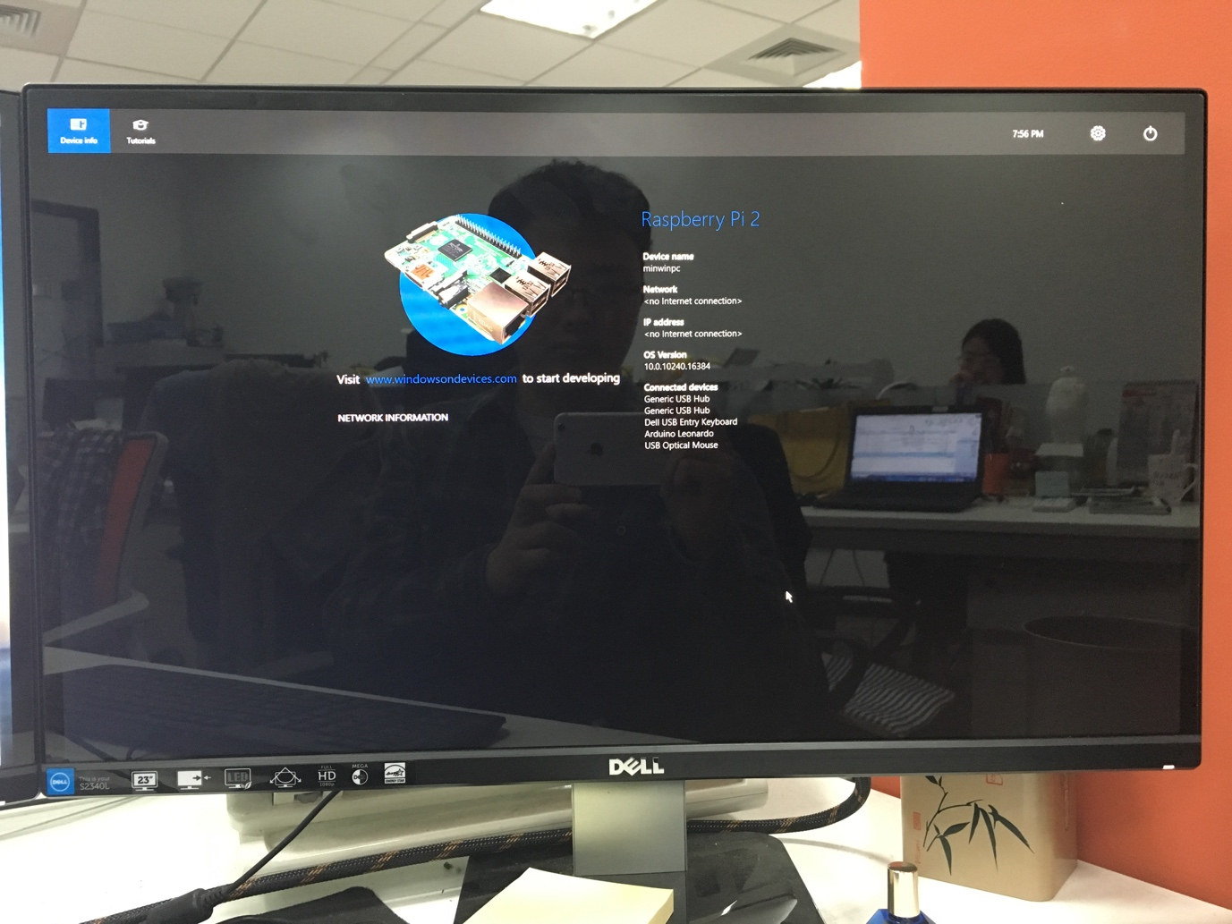

Set up your PC

1. Make sure you are running Windows 10 (version 10.0.10240) or better.
2. Download Visual Studio 2015 Here:

<https://www.visualstudio.com/downloads/download-visual-studio-vs>

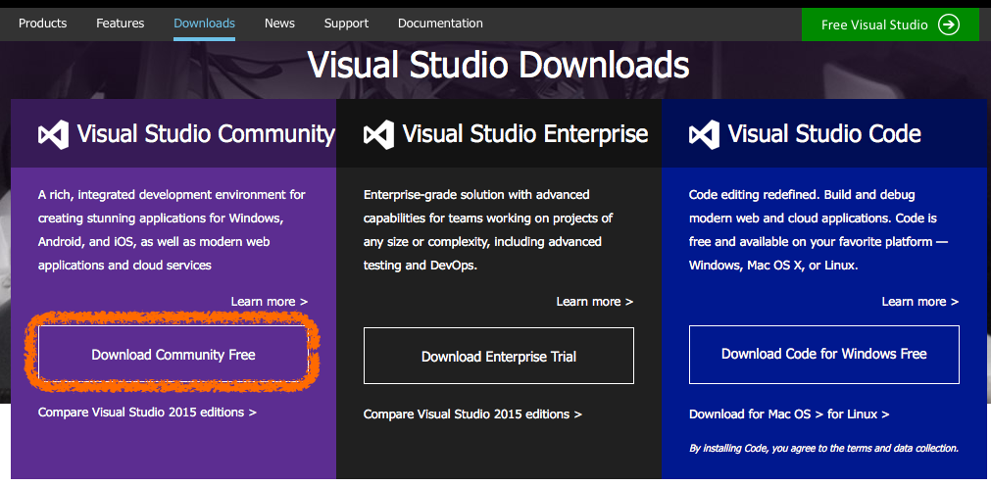

1. Install It, remember to select the “Universal Windows App Development Tools”:

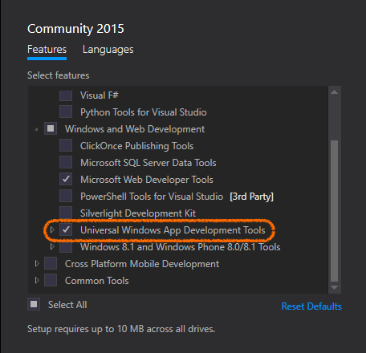

1. Enable developer mode

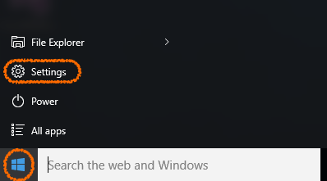 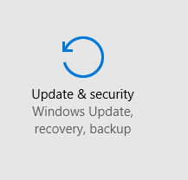

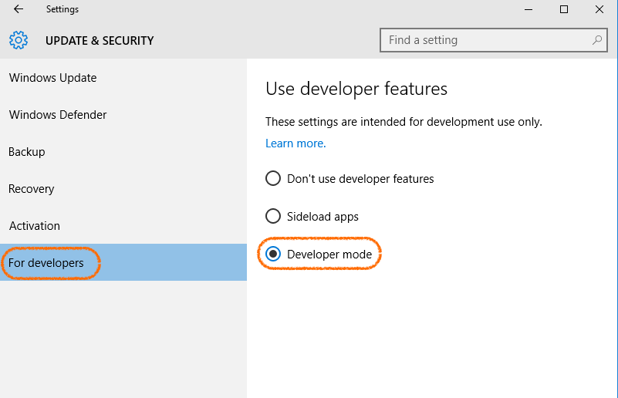

Blink your board:

1. Open Visual Studio 2015 and create a new APP:



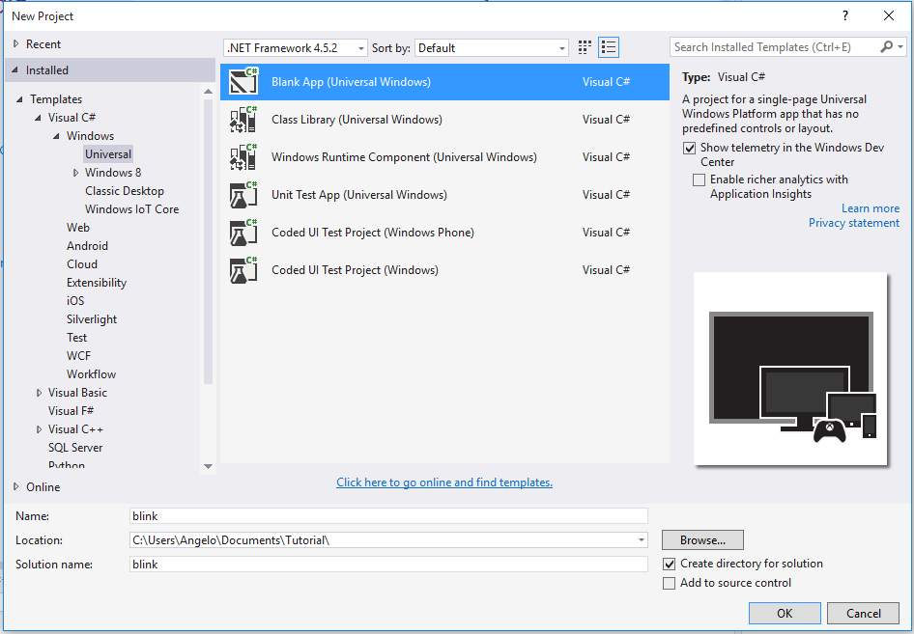

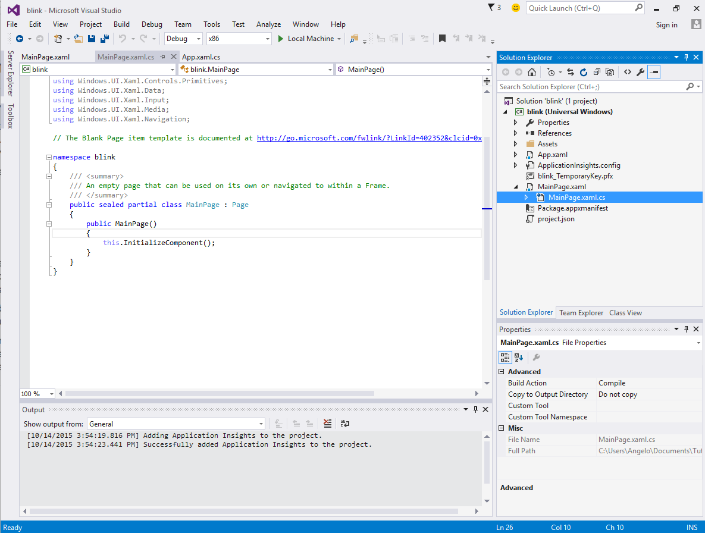

1. NuGet is an easy way to automatically install the packages and setup dependencies. However for the time being (2015/11/2) , Remote wiring doesn’t yet support NuGet in Windows 10. So we have to manually add it.
2. Install the dependent library through NuGet.

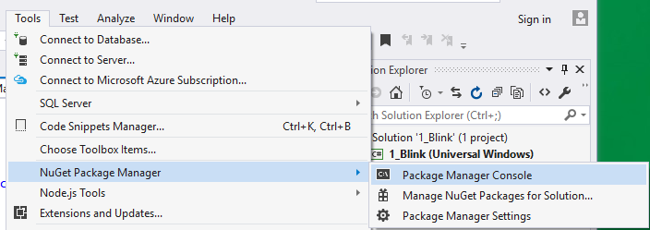

1. Issue the command:

Install-Package Windows-Remote-Arduino

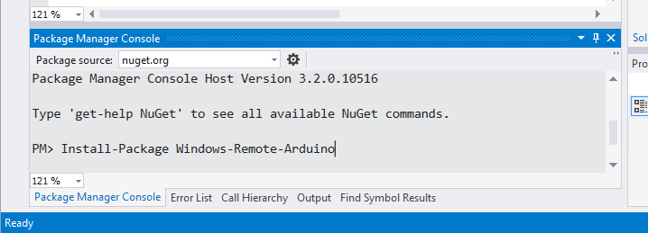

1. Download the dependent library:

<https://github.com/ms-iot/remote-wiring>

1. Decompress the zip file:

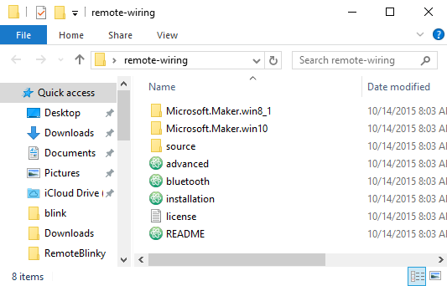

1. Add the reference libraries (Firmata, RemoteWiring, Serial):

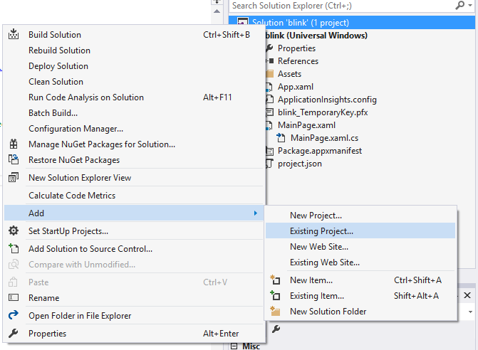

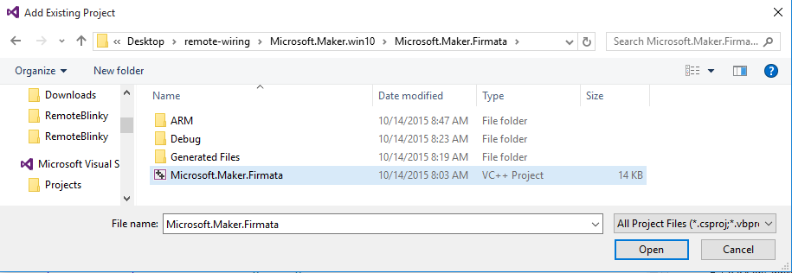

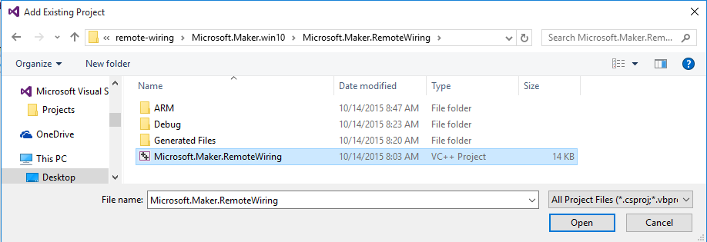





1. Add reference:

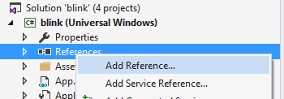

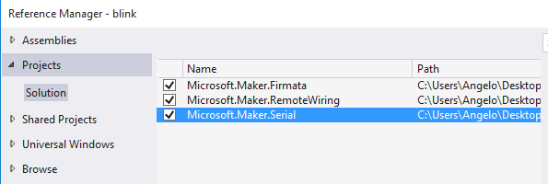

1. Enabling USB Capabilities



1. Add following code here:

<DeviceCapability Name="serialcommunication">

<Device Id="any">

<Function Type="name:serialPort"/>

</Device>

</DeviceCapability>

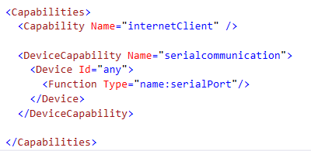

1. Change the Target to ARM:



1. Change the target device to Remote Machine:



1. Select your raspberry Pi on the network

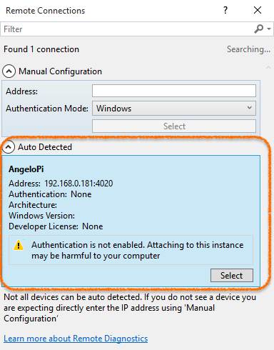

1. Rebuild Solution

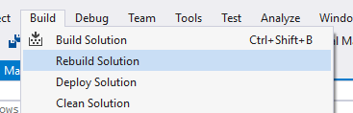

1. 在 MainPage 内键入代码:



using System;

using System.Collections.Generic;

using System.IO;

using System.Linq;

using System.Runtime.InteropServices.WindowsRuntime;

using Windows.Foundation;

using Windows.Foundation.Collections;

using Windows.UI.Xaml;

using Windows.UI.Xaml.Controls;

using Windows.UI.Xaml.Controls.Primitives;

using Windows.UI.Xaml.Data;

using Windows.UI.Xaml.Input;

using Windows.UI.Xaml.Media;

using Windows.UI.Xaml.Navigation;

using Microsoft.Maker.Firmata;

using Microsoft.Maker.RemoteWiring;

using Microsoft.Maker.Serial;

// The Blank Page item template is documented at http://go.microsoft.com/fwlink/?LinkId=402352&clcid=0x409

namespace blink

{

/// <summary>

/// An empty page that can be used on its own or navigated to within a Frame.

/// </summary>

public sealed partial class MainPage : Page

{

UsbSerial usb;

RemoteDevice arduino;

private DispatcherTimer timer;

private const int LED_PIN = 13;

private PinState pinValue;

public MainPage()

{

this.InitializeComponent();

usb = new UsbSerial("VID_2341", "PID_8036"); //I've written in my device D directly

arduino = new RemoteDevice(usb);

usb.ConnectionEstablished += OnConnectionEstablished;

//SerialConfig.8N1 is the default config for Arduino devices over USB

usb.begin(115200, SerialConfig.SERIAL_8N1);

}

private void Timer_Tick(object sender, object e)

{

if (pinValue == PinState.HIGH)

{

arduino.digitalWrite(LED_PIN, PinState.LOW);

pinValue = PinState.LOW;

}

else

{

arduino.digitalWrite(LED_PIN, PinState.HIGH);

pinValue = PinState.HIGH;

}

}

private void OnConnectionEstablished()

{

timer = new DispatcherTimer();

timer.Interval = TimeSpan.FromMilliseconds(1000);

timer.Tick += Timer_Tick;

arduino.pinMode(LED_PIN, PinMode.OUTPUT);

timer.Start();

}

}

}

1. Blink 成功:

